# Bug 1

## All service charges are reported as $0.00 when checking out

### Hypothesis 1

***Test***: service charge is not being converted correctly to a string

***Prediction***: variable ‘total’ is correct value but Double to string conversion for chargeStr doesn’t work

***Result***: Debug break on line 69 of CheckOutCTL.java shows that variable ‘total’ is set as ‘0.00’

### Hypothesis 2

***Test***: ServiceCharge method getCost() is returning zero a value

***Prediction***: De-concatenated code on line 69 so that ServiceCharge.getCost() returns to a dedicated variable for checking value.

***Result***: A debug break on line 70 of CheckOutCTL.java shows that element ‘cost’ is set as ‘0.0’ in ‘charges’ showing the issue lies in ServiceCharge

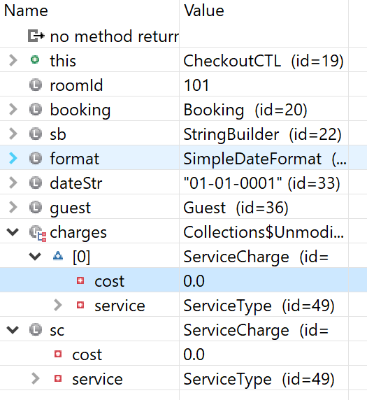

### Hypothesis 3

***Test***: variable ‘cost‘ is not being set correctly in ServiceCharge.java

***Prediction***: the class variable should be set as the same value as the methods incoming argument

***Result***: Data being sent into ServiceCharge is set to 0.0

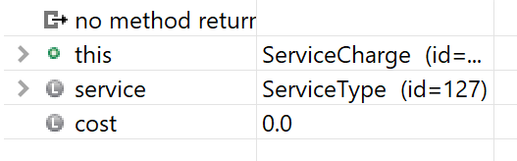

### Hypothesis 4

***Test***: problem in Booking.addServiceCharge()

***Prediction***: The data being sent as arguments to ServiceCharge.add() is insane

***Result***: A debug break on line 142 of Booking.java shows that the variable ‘cost‘ that is being passed into ServiceCharge. add() is set to 0

### Hypothesis 5

***Test***: problem in Booking.addServiceCharge() arguments

***Prediction***: The data being sent into arguments to Booking.addServiceCharge() is insane

***Result***: A debug break on line 142 of Booking.java shows that the argument ‘cosst’ is set to the correct value.

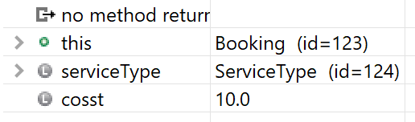

### Hypothesis 6

***Test***: Booking.addServiceCharge() is passing the wrong variable to the ServiceCharge.add() method

***Prediction***: The method is passing the class variable data instead of the method’s argument

***Result***: A debug break on line 142 of Booking.java shows that changing the argument ‘cosst’ to ‘cost’ will now pass the correct value

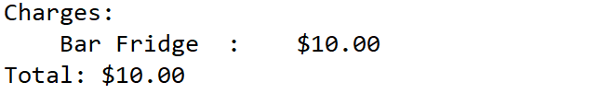

## Bug 2: It is possible to charge a room for service after the guest has checked out

### Hypothesis 1

***Test***: Search for active Booking is comparing insane data in RecordServiceCTL. roomNumberEntered()

***Prediction***: Value for roomNumber is insane and causes a false positive from hotel.findActiveBookingByRoomId()

***Result***: Room number is sane

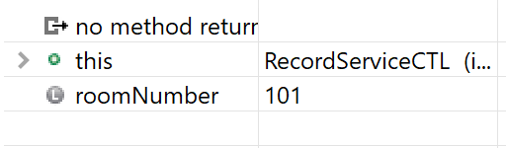

### Hypothesis 2

***Test***: problem lies in Hotel.activeBookingsByRoomId

***Prediction***: Room number still exists in the ‘hash Map

***Result***:

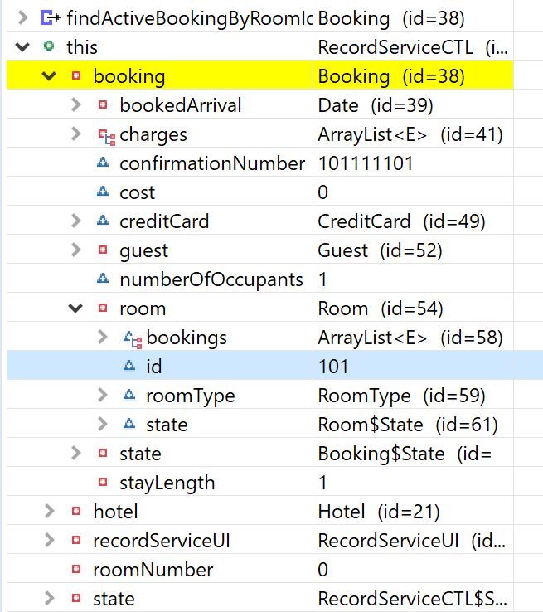

### Hypothesis 3

***Test***:

***Prediction***:

***Result***:

### Hypothesis 4

***Test***:

***Prediction***:

***Result***: